**CHAPTER 1**

**INTRODUCTION**

* 1. **INTRODUCTION TO WEB TECHNOLOGY**

**Web technology** refers to the means by which computers communicate with each other using markup languages and multimedia packages. It gives us a way to interact with hosted information, like websites. **Web technology** involves the use of Hypertext Markup Language (HTML) and Cascading Style Sheets (CSS). In order to make websites look and function a certain way, web developers utilize different languages. The three core languages that make up the World Wide Web are HTML5, CSS and JavaScript.

In the IT world, the Internet is an essential platform, whether it is for developing or for consumer use. When developing a website, typically three main languages come into play. These languages are JavaScript, CSS and HTML. HTML is the backbone of most webpages. Essentially, it is used to create the structure of how a specific website would look like, from the headings, to the paragraphs, the body, links and even images. **Markup languages** are the language in which the web is written. The most common markup language used is HTML, which uses tags to annotate text so that a computer can then manipulate the text. Most markup languages are human readable, and use annotations that are distinguished from the annotated text. There are many different kinds of markups and languages, but all are consistent in the way in which they annotate documents

**Hypertext** is defined as the arrangement of information inside a database that allows the user to receive information and to navigate from one document to another by clicking on highlighted words or pictures inside the primary document. Hypertext is the base of the World Wide Web, because it enables user to click on other links to get more information. Hypertext is a term used for all terms, whether it appears as text or other graphical part.

**HTML** is the conventional markup language used to create and edit web pages and web applications. HTML is used for creating the basic structure of a website. HTML consists of different elements preceded by an opening tag, <tag>, and a closing tag, <**/**tag>. The content between the tags, <html> and <**/**html>, is the content of the webpage. The content between the tags, <head> and <**/**head>, is the title of the webpage. This text is displayed between the <title> and <**/**title> tags. The content between the tags, <body> and <**/**body>, is the main content of the webpage. The content can include links, paragraphs, headings, and various other elements.

**CSS** is a style sheet language standard set by W3C (World Wide Web Consortium) used to create and edit the visual presentation of web pages. CSS allows web developers to isolate a web page’s content and visual styles into separate documents and gives better page layout control. An external CSS sheet is generally lined to HTML and XHTML, it can also be linked to XML, SVG and XUL. HTML and JavaScript, with CSS, is a vital part of technology used by the majority of interfaces for websites. This is also used in interfaces for mobile devices making the websites more engaging.

CSS can be incorporated with HTML in three different ways: Inline, Internal and External.

1. **Inline styles** add style to a single element on the page by placing ‘style’ after the element you wish to be styled.

Ex**:** h2 style=”color:blue”

1. **Internal styles** create a style for a single document because the CSS is stored in the head of the HTML document. Internal styles are placed using a **<style>** tag around all style selectors.

Ex**:** <style>

body {background-color:white;}

**/**\* This is a comment!

‘body’ is the selector,

‘background-color’ is the declaration \***/**

h2 {color:blue;}

<**/**style>

1. **External style sheets** exist in separate documents from HTML, documents, allowing for better organization of style and structure. An external style sheet can be linked to all HTML documents making up a web site, allowing a web developer to style the entire site (all pages) using one document.

**JavaScript** is a scripting language that is used along with HTML and CSS as the three core components of the World Wide Web. JavaScript has first - class functions and is used in most websites. JavaScript does not have any I/O which means that it has to be embedded in the host environment. JavaScript is also used in PDF documents, game development, and desktop and mobile applications. JavaScript is most commonly used to make DHTML by adding client-side behaviour to HTML pages.

**PHP** stands for Hypertext Processor (no, the acronym doesn’t follow the name). It is an **open source, server**-side, scripting language used for the development of web applications. By scripting language, we mean a program that is script – based (lines of code) written for the automation of tasks.

* 1. **OVERVIEW OF THE PROJECT**
     1. **MOTIVATION**

The long queues at salons due to the absence of an organised management system. Inspired us to build Curlz-Salon and Spa Reservation system .

* + 1. **PROBLEM STATEMENT**

To demonstrate a simple Curlz-Salon and Spa Reservation Management System and its working using web technologies.

* + 1. **OBJECTIVES OF THE PROJECT**
* To demonstrate secure access to the system.
* To demonstrate insertion, deletion and update operations on the system with suitable warnings thrown for inappropriate actions.
* To demonstrate the use of HTML, CSS, JavaScript and PHP in developing a web application.
* To demonstrate the overall working of a basic Salon and Spa Reservation Management System.
  1. **SUMMARY**
* The three core languages that make up the World Wide Web are HTML5, CSS and JavaScript.
* PHP is an **open source, server**-side, scripting language used for the development of web applications.

**CHAPTER 2**

**REQUIREMENT SPECIFICATION**

A software requirement by definition is an abstract description of the services which the system should provide, and the constraints under which the system must operate. It should only specify the external behaviour of the system.

**2.1 FUNCTIONAL REQUIREMENTS**

In software engineering, a **functional requirement** defines a function of a software system or its component. A function is described as a set of inputs, the behaviour and outputs (see also software). Functional requirements may be calculations, technical details, data manipulation and processing and other specific functionality that define *what* a system is supposed to accomplish. Behavioural requirements describing all the cases where the system uses the functional requirements are captured in use cases.

The following are the functional requirements:

* The ability to perform the correct operation when the corresponding functions are called.
* When the function is called, the corresponding actions should be performed.
* The ability to store the data in the database when the input is fed from the front-end.

**2.2 NON-FUNCTIONAL REQUIREMENTS**

These are constraints on the services or functions offered by the system. They include timing constraints, constraints on the development process and standards. Non-functional requirements apply to the system as a whole.

Non-functional requirements are as follows:

* Dependability
* Availability
* Reliability
* Safety
* Security

**Dependability:**

The dependability of a computer system is a property of the system that equates to its trustworthiness. Trustworthiness essentially means the degree of user confidence that the system will operate as they expect and that the system will not ‘fail’ in normal use.

**Availability:**

The ability of the system to deliver services when requested. There is no error in the program while executing the program.

**Reliability:**

The ability of the system to deliver services as specified. The program is compatible with all types of operating system without any failure.

**Safety:**

The ability of the system to operate without catastrophic failure. This program is user friendly and it will never affect the system.

**Security:**

The ability of the system to protect itself against accidental or deliberate intrusion.

**2.3 SYSTEM REQUIREMENTS**

**HARDWARE REQUIREMENTS**

* **PROCESSOR :** Pentium Quad-Core, i3, i5 or higher
* **RAM :** 2 GB or higher
* **DISK SPACE :** 10 GB or more

**SOFTWARE REQUIREMENTS**

* **OPERATING SYSTEM:** Windows 7,8 or 10
* **LANGUAGE**  **:** HTML, CSS, PHP and JavaScript
* **DATABASE :** MySQL(XAMPP)

**2.4 SUMMARY**

* A software requirement by definition is an abstract description of the services which the system should provide, and the constraints under which the system must operate.
* For this project the system must have a browser installed supporting HTML, CSS, and JavaScript enabled.
* A local host server is set up by means of an application such as WAMP or XAMPP.

**CHAPTER 3**

**3.1 ANALYSIS AND DESIGN**

The below figure depicts the flow of data in the system. It describes the relationship between user input and system behaviour.

Users

Front End Presentation Layer

Database Access Layer

Database

Back End Presentation Layer

Admin

**Figure 3.1: Flowchart for Salon and Spa Reservation Management System**

**FRONT END/ USER INTERFACE:**

**HTML** is the conventional markup language used to create and edit web pages and web applications. HTML is used for creating the basic structure of a website. HTML consists of different elements preceded by an opening tag, <tag>, and a closing tag, <**/**tag>. The content between the tags, <html> and <**/**html>, is the content of the webpage. The content between the tags, <head> and <**/**head>, is the title of the webpage. This text is displayed between the <title> and <**/**title> tags. The content between the tags, <body> and <**/**body>, is the main content of the webpage. The content can include links, paragraphs, headings, and various other elements.

**CSS** is a style sheet language standard set by W3C (World Wide Web Consortium) used to create and edit the visual presentation of web pages. CSS allows web developers to isolate a web page’s content and visual styles into separate documents and gives better page layout control. An external CSS sheet is generally lined to HTML and XHTML, it can also be linked to XML, SVG and XUL. HTML and JavaScript, with CSS, is a vital part of technology used by the majority of interfaces for websites. This is also used in interfaces for mobile devices making the websites more engaging.

CSS can be incorporated with HTML in three different ways: Inline, Internal and External.

1. **Inline styles** add style to a single element on the page by placing ‘style’ after the element you wish to be styled.

Ex**:** h2 style=”color:blue”

1. **Internal styles** create a style for a single document because the CSS is stored in the head of the HTML document. Internal styles are placed using a **<style>** tag around all style selectors.

Ex**:** <style>

body {background-color:white;}

**/**\* This is a comment!

‘body’ is the selector,

‘background-color’ is the declaration \***/**

h2 {color:blue;}

<**/**style>

1. **External style sheets** exist in separate documents from HTML, documents, allowing for better organization of style and structure. An external style sheet can be linked to all HTML documents making up a web site, allowing a web developer to style the entire site (all pages) using one document.

**JavaScript** is a scripting language that is used along with HTML and CSS as the three core components of the World Wide Web. JavaScript has first - class functions and is used in most websites. JavaScript does not have any I/O which means that it has to be embedded in the host environment. JavaScript is also used in PDF documents, game development, and desktop and mobile applications. JavaScript is most commonly used to make DHTML by adding client-side behaviour to HTML pages.

**PHP** stands for Hypertext Processor (no, the acronym doesn’t follow the name). It is an open source, server-side, scripting language used for the development of web applications. By scripting language, we mean a program that is script – based (lines of code) written for the automation of tasks.

**BACK END/ DATABASE:**

The database which represents the Departmental Store Inventory Management System is accessed by means of PHP code.

The administration of MySQL is handled by PhpMyAdmin, which allows the user to graphically create, modify or delete databases, tables, fields or rows executing SQL statements. This may be used to create a database initially, to implement the schema.

The MySQL server is set up by means of an application such as WAMP or XAMPP.

MySQL is an open source relational database management system. The main advantages of DBMS system are controlling redundancy, restricting unauthorized access, providing persistent storage structures and ease of search. Techniques for efficient query processing are providing backup and recovery, providing multiple user interfaces, representing complex relationships among data.

**3.2 SUMMARY**

* The system design consisting of the front-end and back-end specifications is described here.

**CHAPTER 4**

**SYSTEM IMPLEMENTATION**

To implement this project, MySQL is used for back-end and is implemented through XAMPP Server and HTML, CSS and JavaScript are used to implement the front-end (GUI).

The connection has been implemented through means of PHP.

**4.1 MODULE DESCRIPTION**

**1. Log-in Page:**

**INPUT:**

Username and password

**OUTPUT:**

A successful log-in allows access to the general overview page, else a suitable error message is thrown.

**DESCRIPTION:**

Front end is designed using HTML and CSS. The log-in page has a form to accept username and password. On entering these parameters, click on Login button. If the entered credentials are correct, then the user can access the general overview page. Otherwise suitable error message will be displayed. The user can then place his orders and if he wishes, he can proceed to checkout.

**2. Account Creation Page**

**INPUT:**

Personal name of the user, a username and the password.

**OUTPUT:**

A successful creation of the user account.

**DESCRIPTION:**

The user can create an account using which he can access the database. Here the username must be unique, and if a duplication is attempted, an error message is shown.

**3. Admin Log-in Page:**

**INPUT:**

Username and password

**OUTPUT:**

A successful log-in allows access to the general overview page, else a suitable error message is thrown.

**DESCRIPTION:**

The admin log-in page has a form to accept username and password. On entering these parameters, click on Login button. If the entered credentials are correct, then the admin can access the general overview page and see all the user bookings. Otherwise suitable error message will be displayed. Additionally, admin can view the feedbacks and comments given by the users.

**4.2 SUMMARY**

* The system is divided into 3 primary modules for User Login, User Sign-up and admin module.
* The first two modules deals with the user capabilities on the web page and third module describes the administrative privileges over the website.

**CHAPTER 5**

Testing is a process of executing a program with the aim of finding error. To make our software perform well it should be error free. If testing is done successfully it will remove all the errors from the software. Unit testing was performed to eliminate errors in individual units of code.

Upon completion Integration testing and System testing was performed to ensure all functions are working error free.

The below tabulation shows results of testing performed.

**TESTING**

|  |  |  |  |  |
| --- | --- | --- | --- | --- |
| **No.** | **Functions** | **Expected Result** | **Actual Result** | **Comments** |
| 1 | Sign Up Page | The user must enter the appropriate credentials and on signing in, he goes back to the home page | The user goes back to the home page. | PASS |
| 2 | Login Page | The user enters the correct credentials and logs into the main page. | The user goes to the main page. | PASS |
| 3 | Admin Login | The admin enters his credentials and logs into his main page. | The admin goes to his main page. | PASS |
| 4 | About Page | The user or admin can check the about page. | The about page is displayed. | PASS |
| 5 | Admin’s Operations | Admin can view all the confirmed bookings and read feedbacks & comments. | The Bookings are viewed and can see all the feedbacks | PASS |
| 6 | User’s Operations | User can place orders from the packages, upon finalizing his orders, he can see his bill. | Appropriate bill is printed. | PASS |

**Table 5.1: Testing Results.**

**CHAPTER 6**

**RESULTS AND SCREENSHOTS**

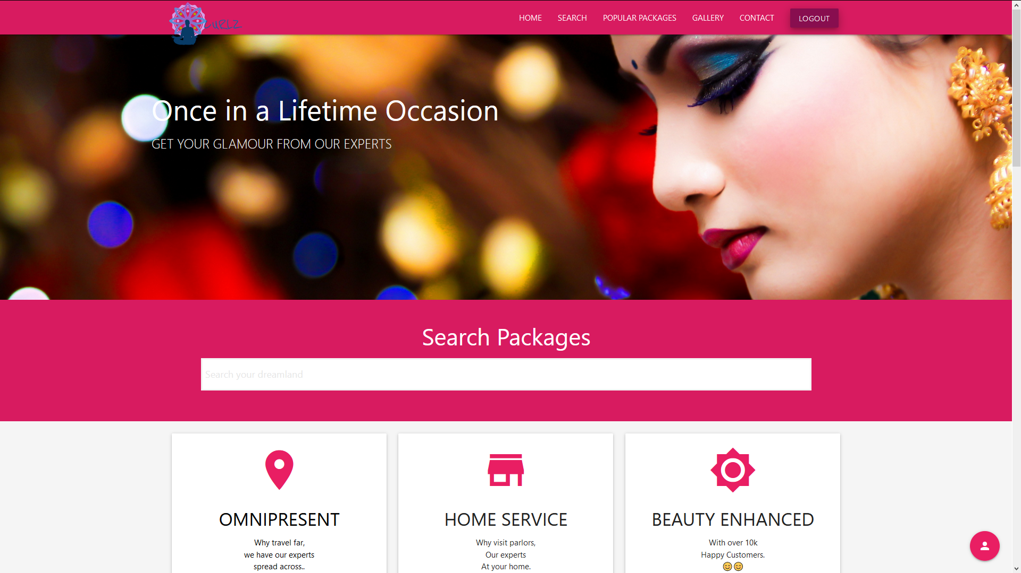

**Figure 4.1: HOME PAGE**

The above figure represents the Home Page of the website.

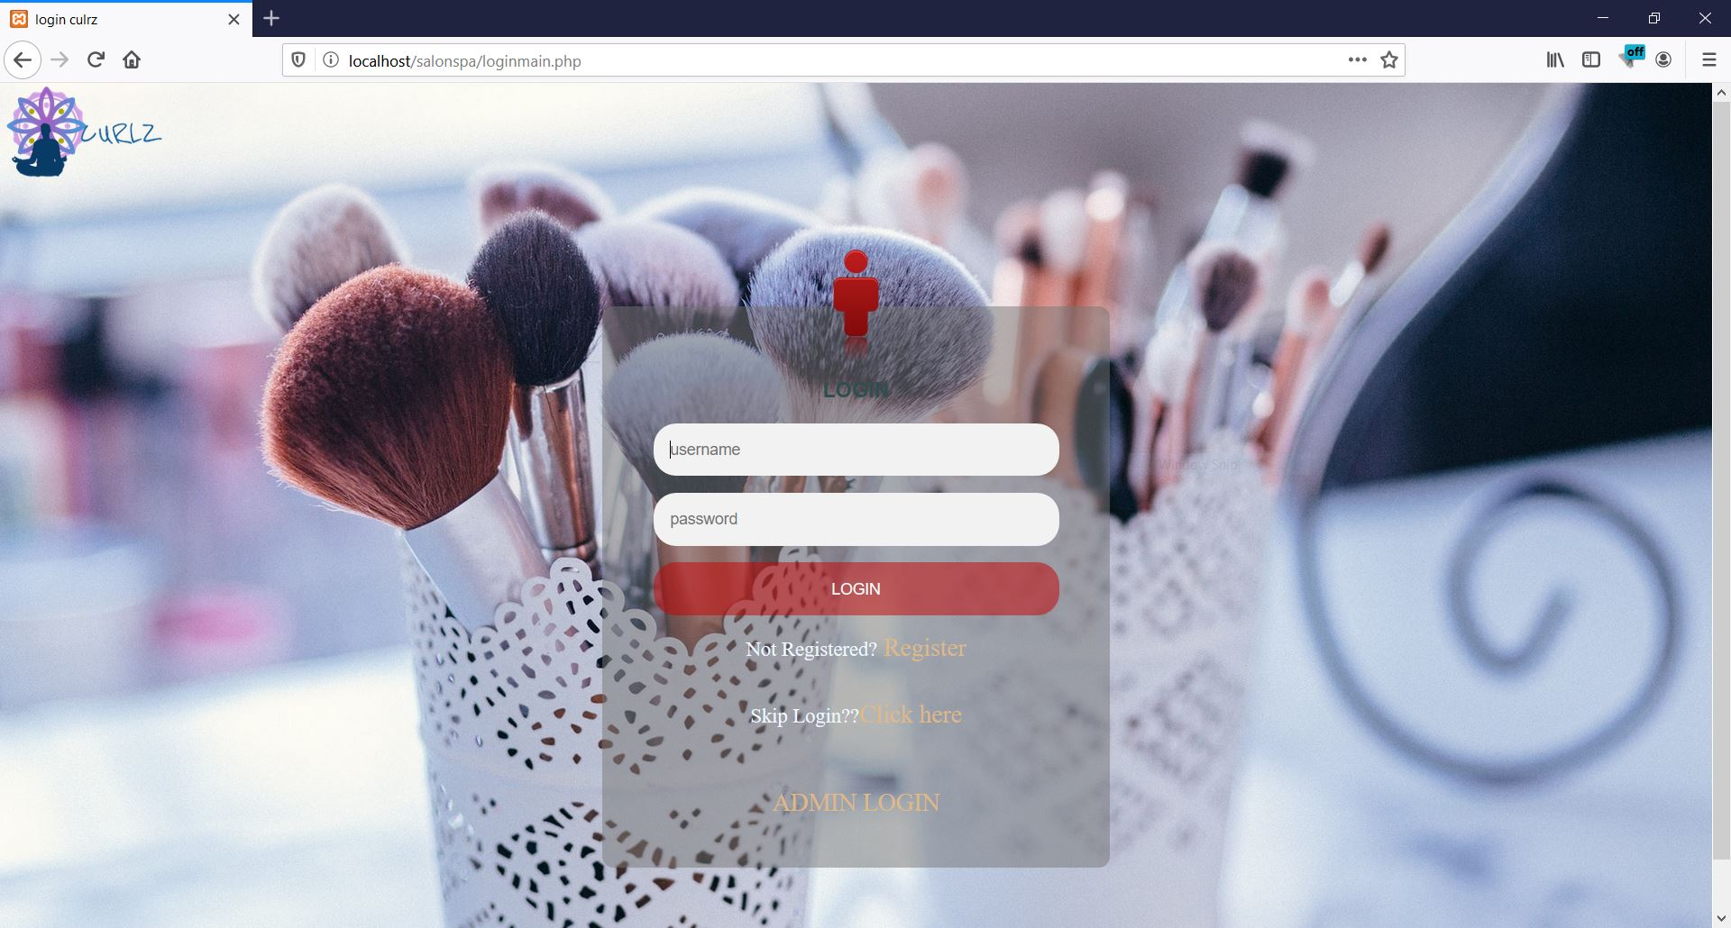

**Figure 4.2: USER LOGIN**

Shows the user login page and signup button.

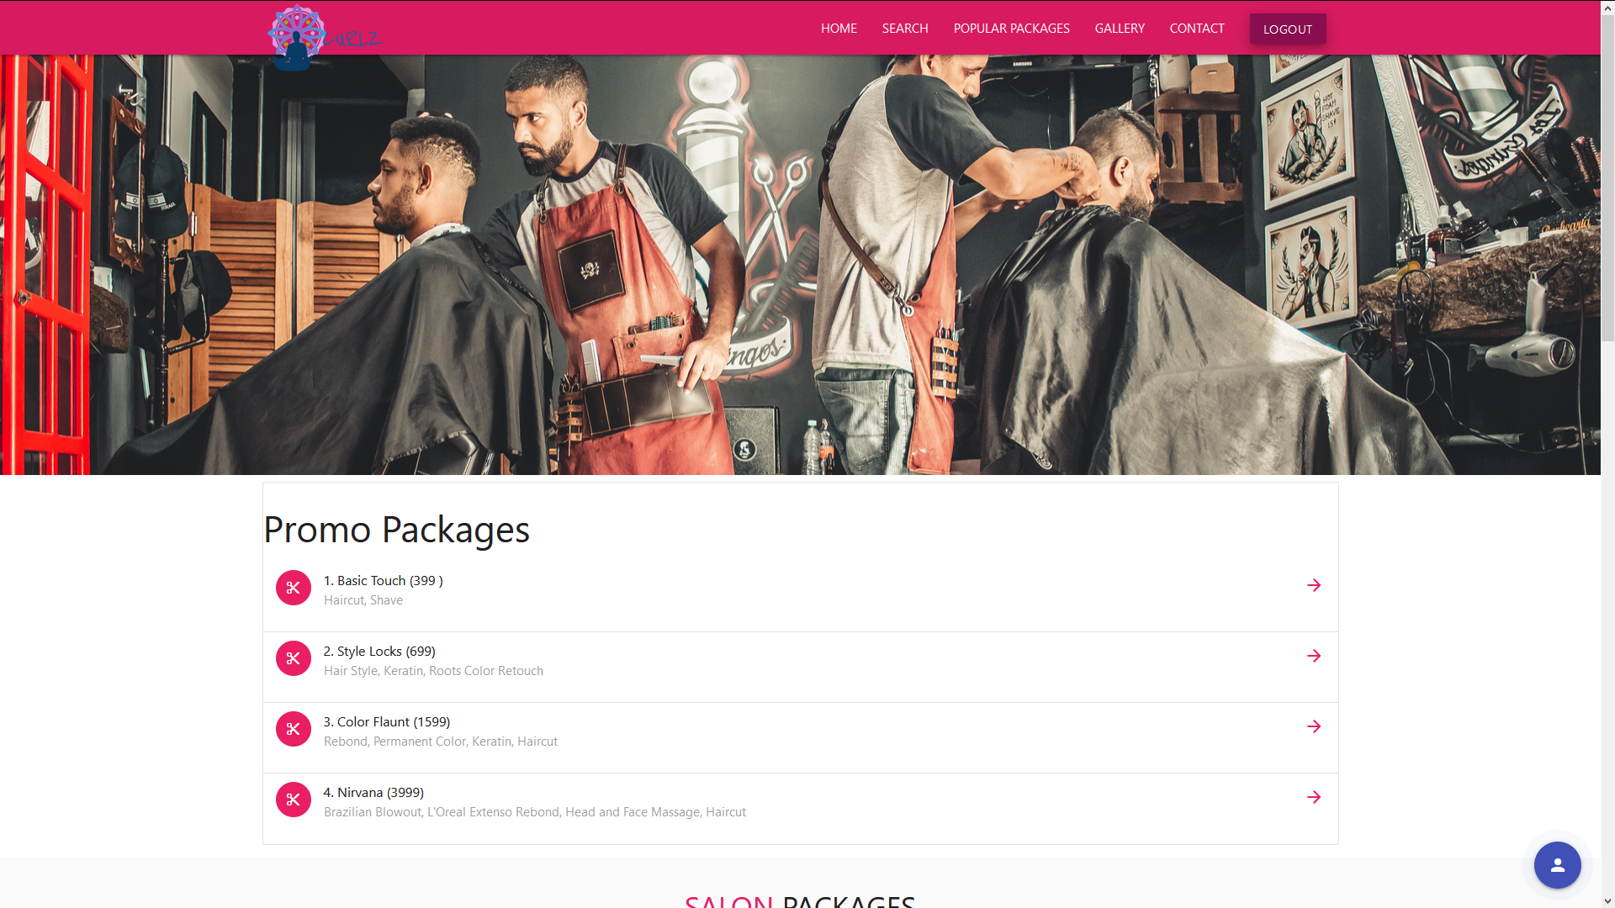

**Figure 4.3: LISTS OUT THE PACKAGES**

Figure depicts the list of featured packages available.

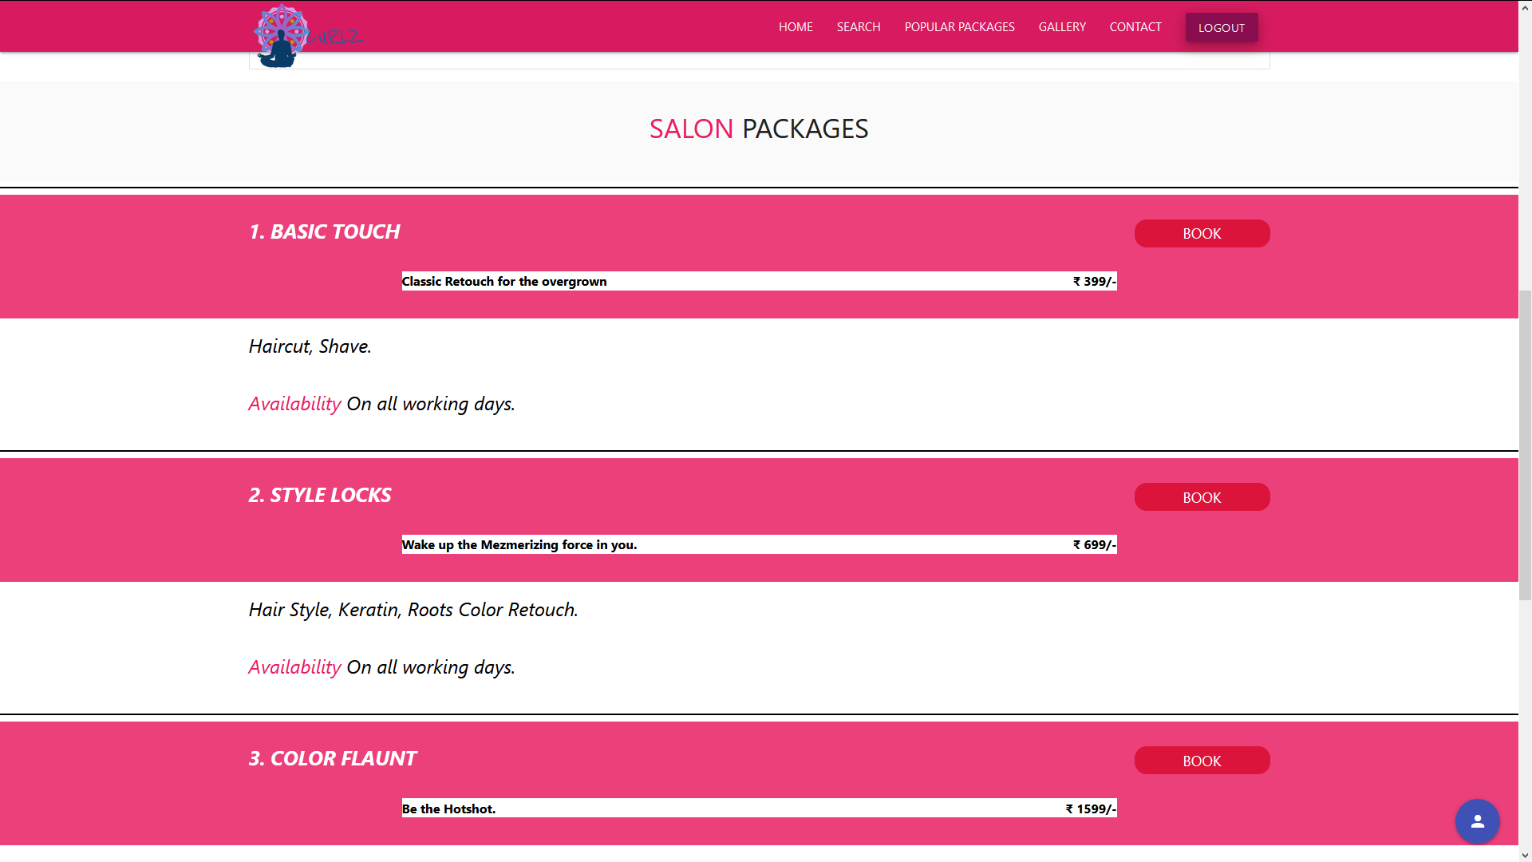

**Figure 4.4: DETAILS ABOUT THE PACKAGES**

Figure shows details about package contents and provides options to book from.

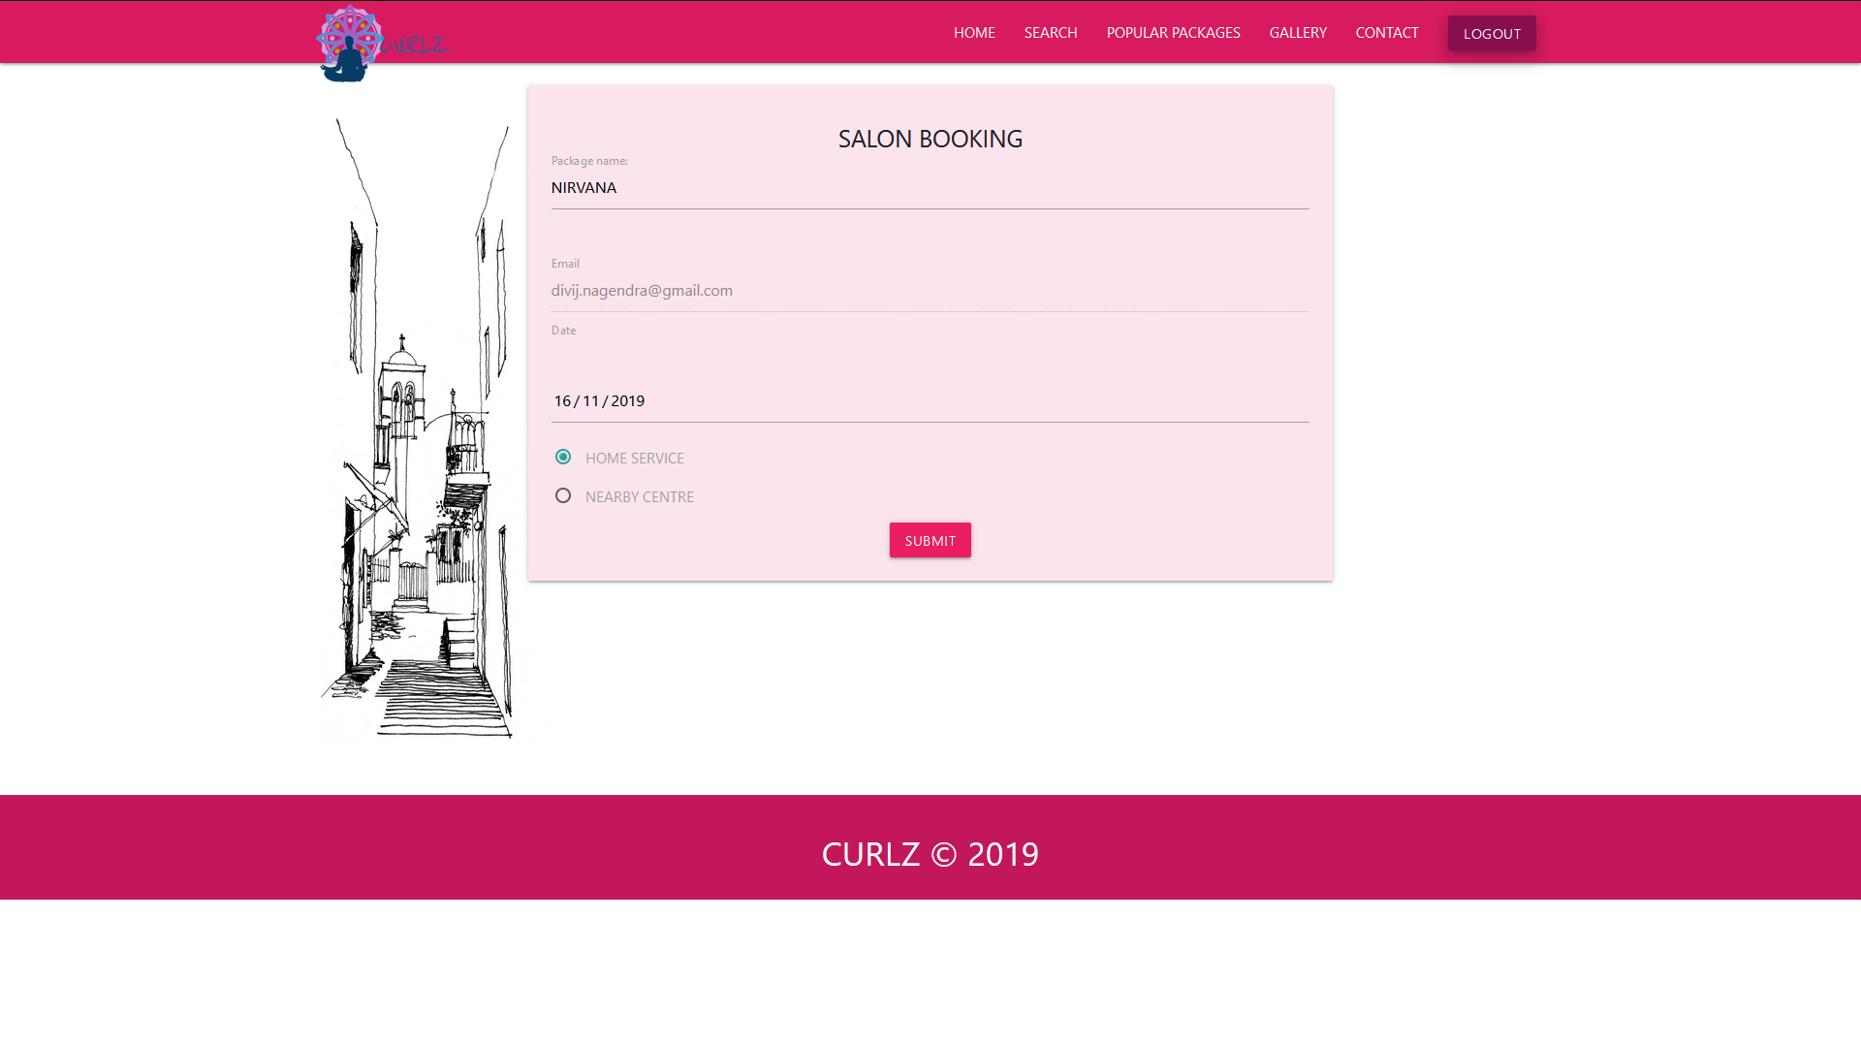

**Figure 4.5: BOOKING DETAILS**

This page is for users to fill the details regarding his or her package booking.

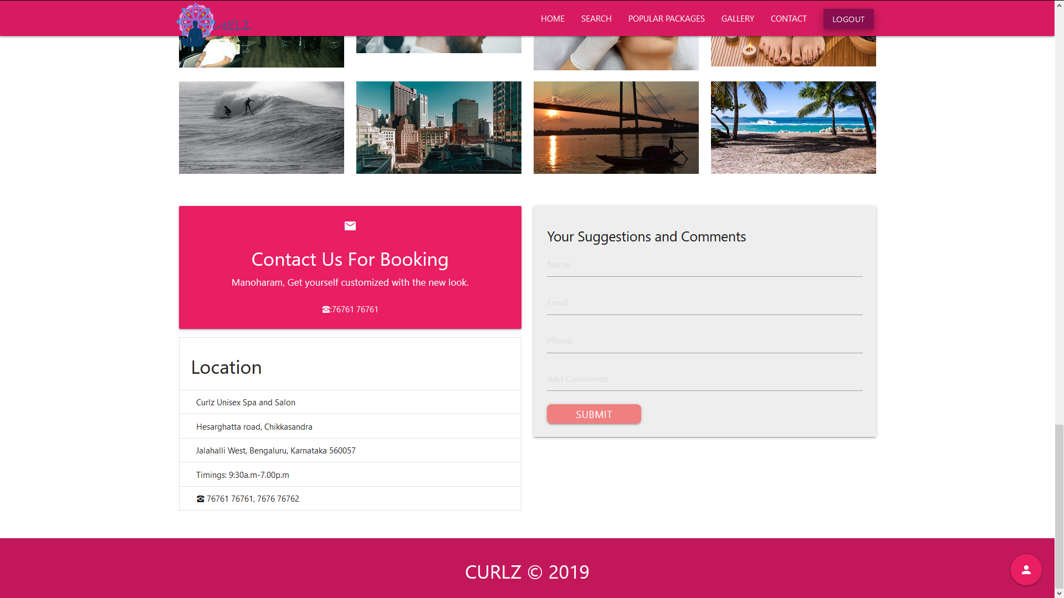

**Figure 4.6: COMMENTS AND SUGGESTIONS**

Provides users to submit their feedback and share their experience with admin.

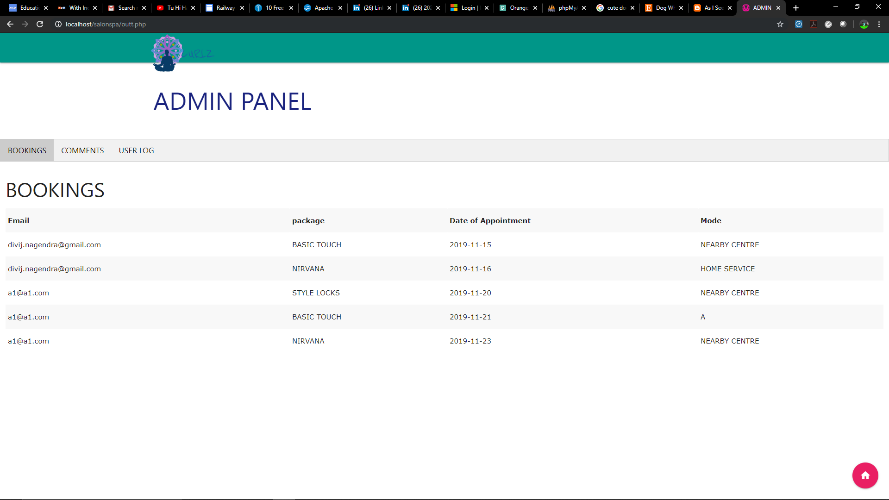

**Figure 4.7: ADMIN PANEL: BOOKINGS**

Admin can view all the confirmed bookings from this panel.

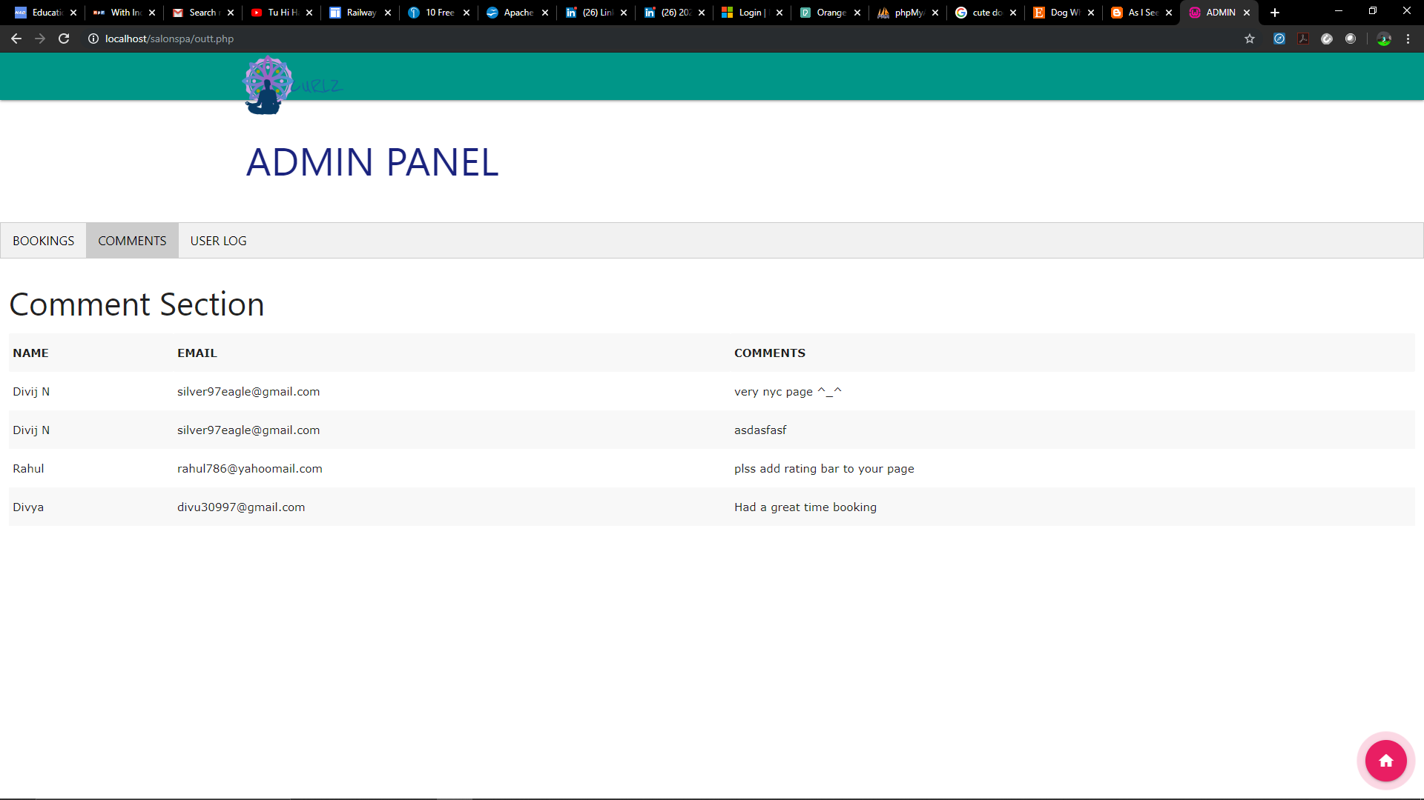

**Figure 4.8: ADMIN PANEL: COMMENTS AND SUGGESTIONS**

Admin can view all the user feedbacks in this section. The user’s name and email is shown so as to contact if necessary.

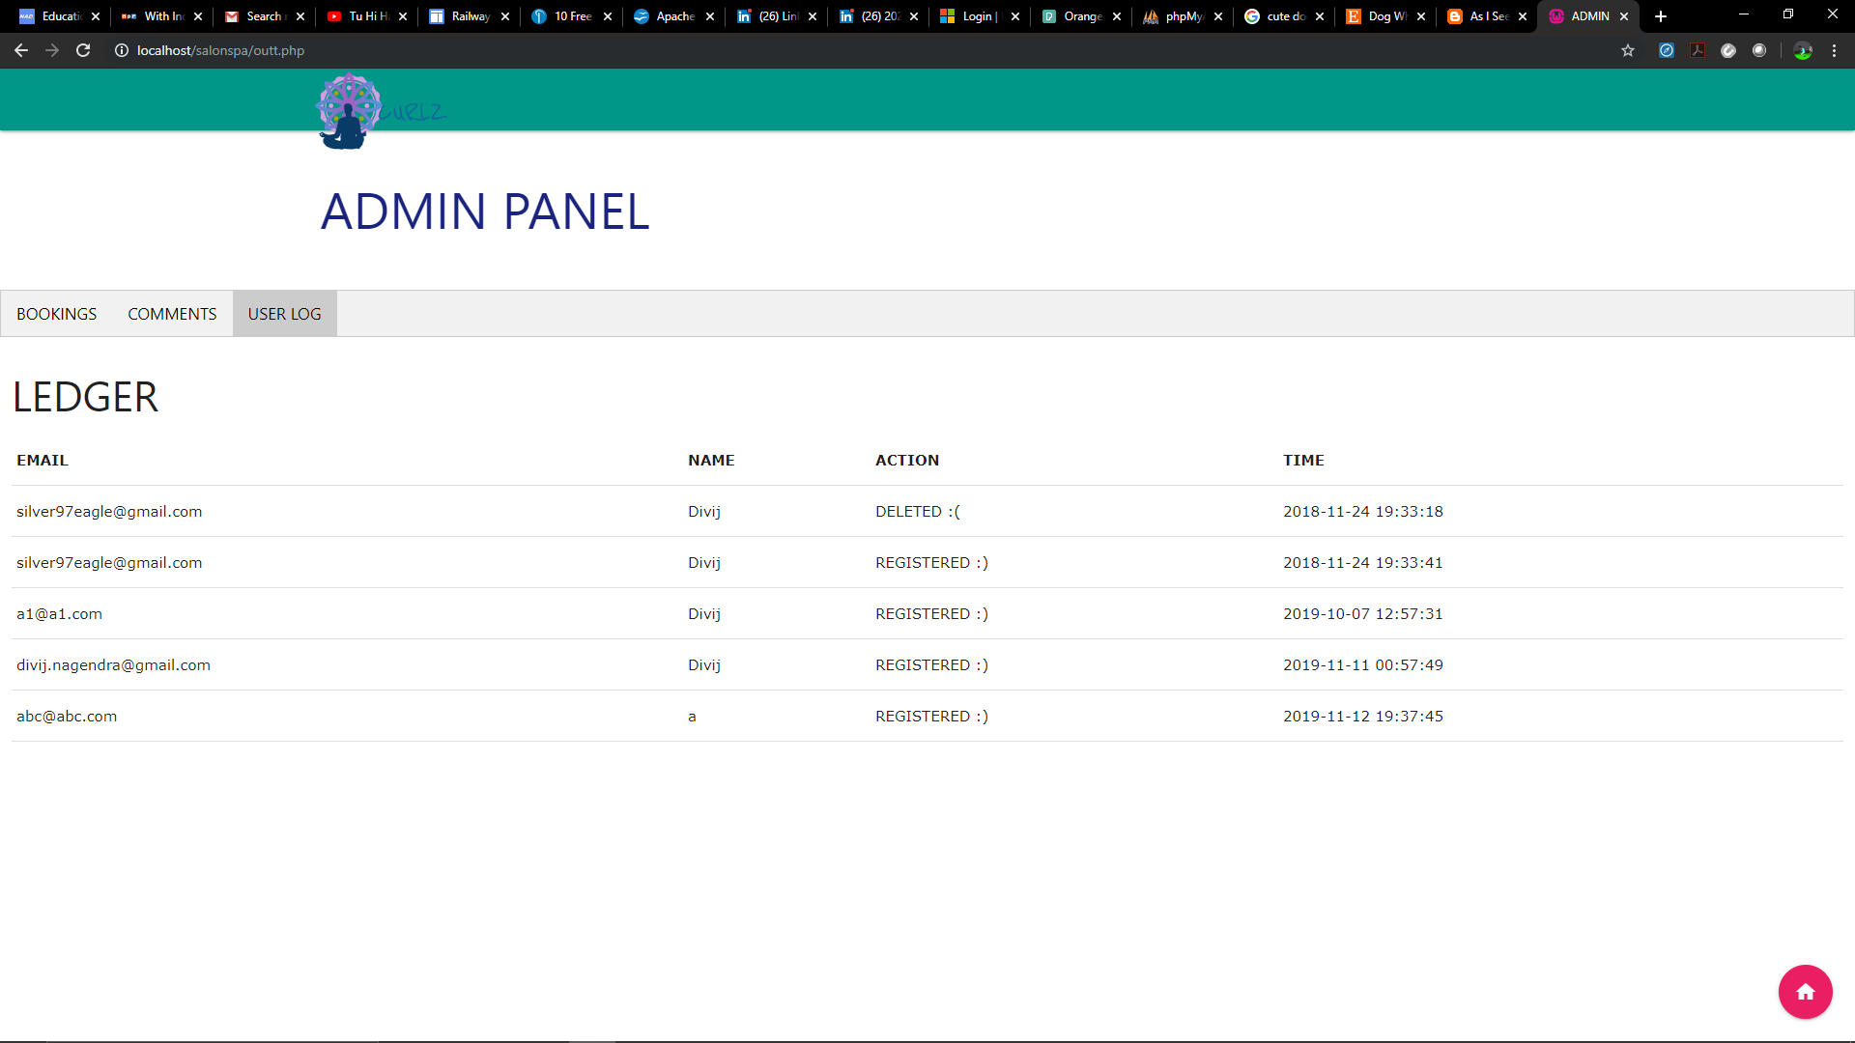

**Figure 4.9: ADMIN PANEL: USER LOG**

The user can see record of all the users who have registered with them.

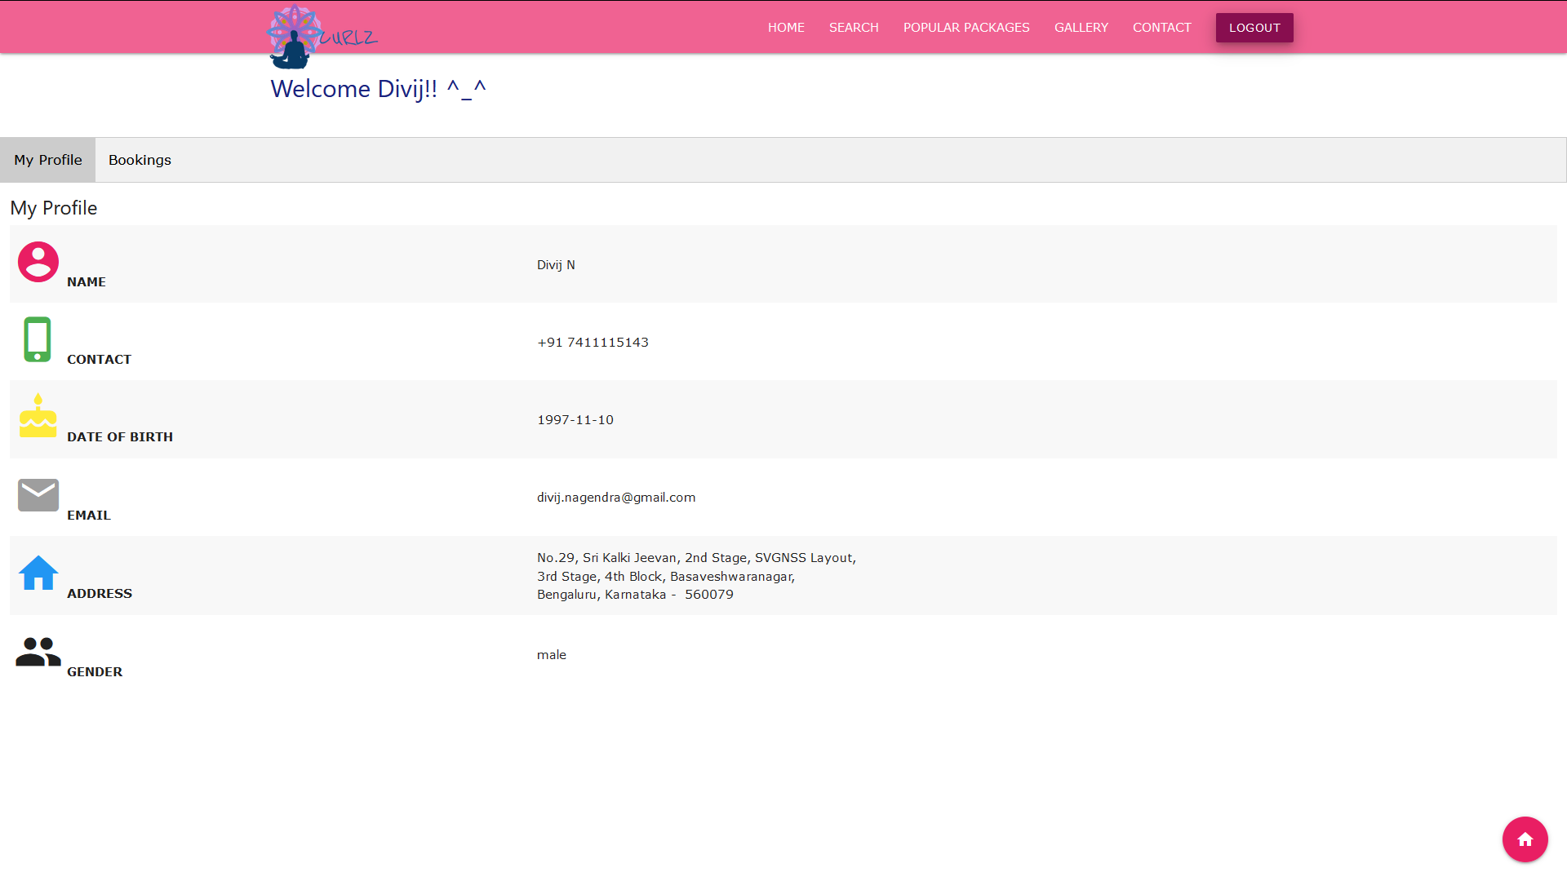

**Figure 4.10: USER PROFILE**

This page gives the details about account holder i.e. User Profile information.

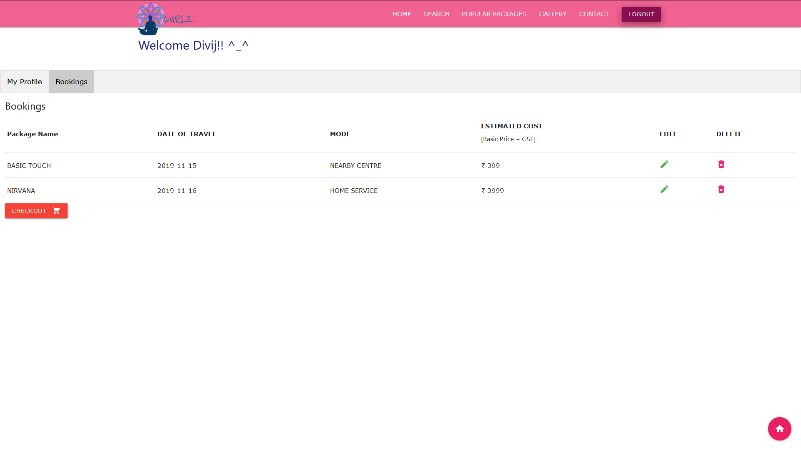

**Figure 4.11: USER’S BOOKING CART**

Above figure displays the details of the order. Also the user can edit or delete his booking here. Once the user is satisfied with his orders, he can proceed to checkout.

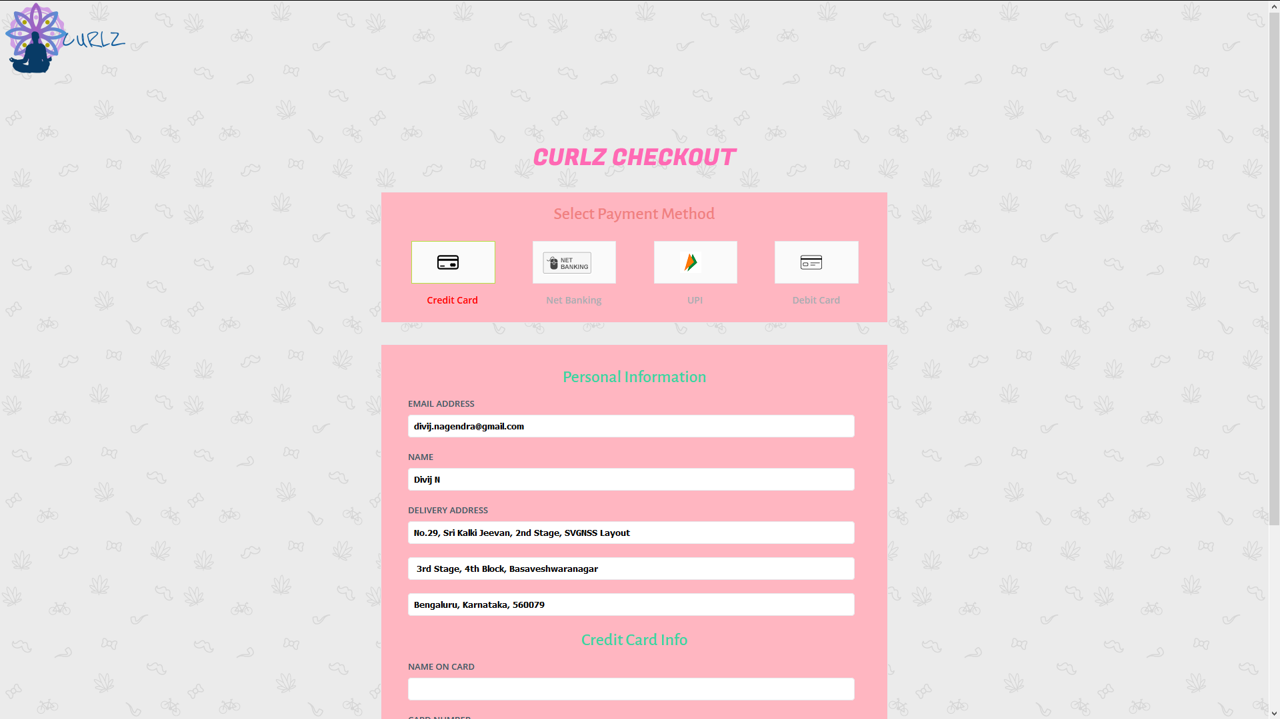

**Figure 4.12: CHECKOUT PAGE FOR USER’S ORDERS**

Figure depicts the various payment options to confirm user booking.

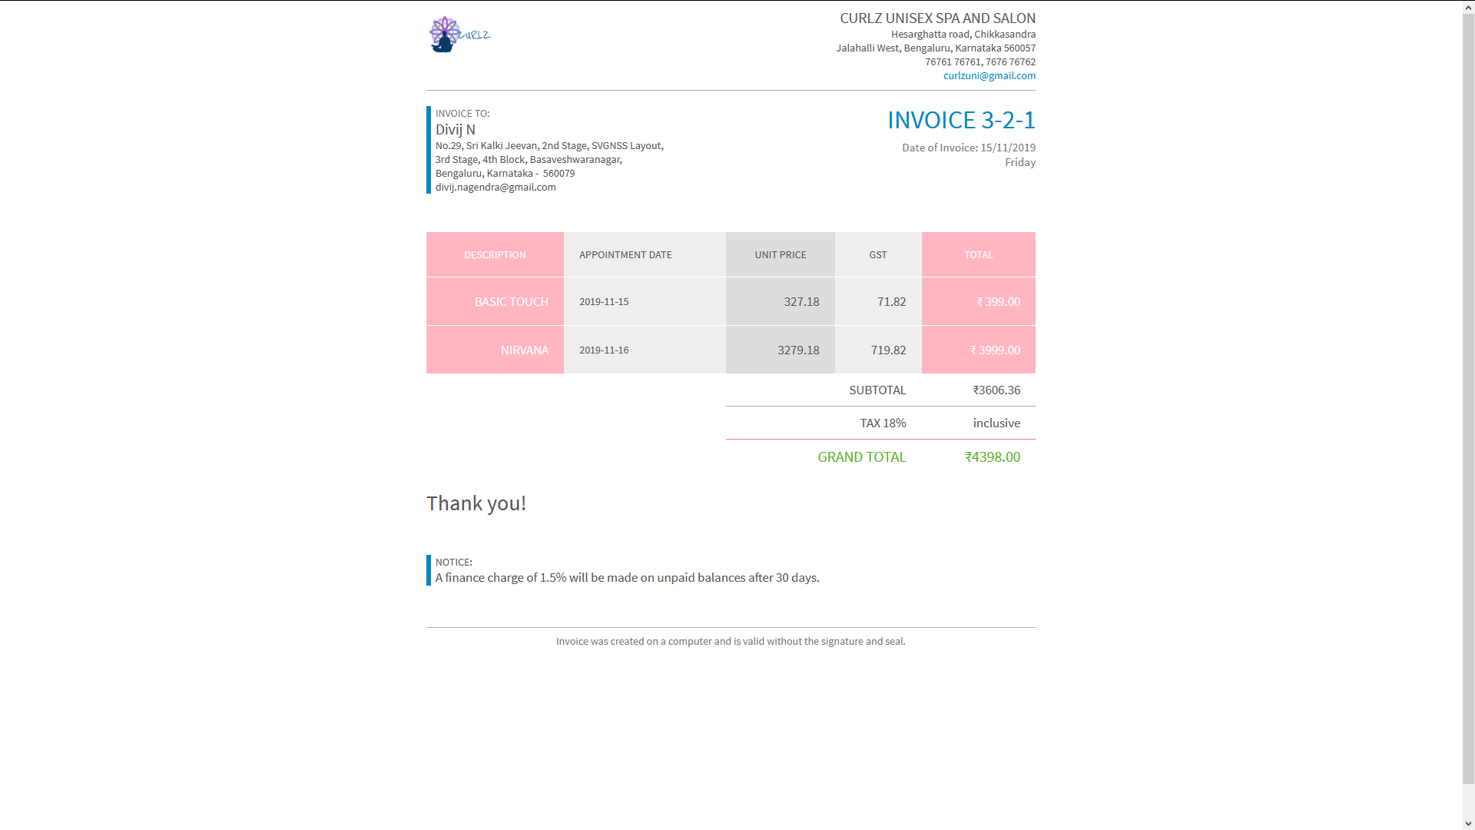

**Figure 4.13: INVOICE CONSISTING OF BILL AMOUNT FOR THE USER**

This figure shows the bill amount with tax, billing date and time for the current user.

**CONCLUSION**

The application has been developed using SQL, HTML, CSS and JavaScript, with the connectivity being achieved through the use of PHP. Materialize CSS framework has been used to improve the GUI. This is an attempt to show how a basic Salon and Spa reservation management system works .And also, showcases the data being accessed, retrieved and manipulated very easily through the help of the user-friendly interface developed.

**BIBLIOGRAPHY**

[1] [www.google.com](http://www.google.com)

[2] [www.youtube.com](http://www.youtube.com)

[3] [www.stackoverflow.com](http://www.stackoverflow.com)

[4] [www.materializecss.com](http://www.materializecss.com)

[5] www.w3schools.com